Standard Operating Procedure
and
Club Management Document
for
Strathclyde Loch Sailing Club

Table of Contents
1 Introduction to Club 3
1.1 Club Objective and History 3
2 Sailing Activities 4
2.1 Training 4
2.2 Leisure Sailing 4
2.3 Racing 4
3 Facilities 5
3.1 Club and Members Boats 5
3.2 Club House 5
3.3 Changing Facilities and Clothing 5
3.4 Training room 6
3.5 First Aid and Defibrillator 6
4 Loch Sailing Areas and Conditions 8
4.1 Sailing Area 8
4.2 Water Conditions Flag Good 9
4.3 Water conditions Flag Poor 10
4.4 Positioning of Racing Markers 11
5 Dealing with a Major Incident 12
5.1 Emergency Action Plan 12
5.2 Major Incidents Procedure 13
6 Procedures and checklists 15
6.1 Training Centre 15
6.2 Committee Boat and Safety Boat refuelling Procedure 17
6.3 Training Boats Rigging / Launching and Recovery 17
6.4 Club Safety Boat Launch/ Recovery Procedure 18
6.5 Committee Boat Launch Procedure 20
7 Index of Appendices 24
52

Introduction to Club

Club Objective and History
Strathclyde Loch Sailing club was set up in 1978 to establish a safe and friendly club to promote training, sailing and racing. The club is affiliated with the Royal Yachting Association (RYA) and is also an RYA Recognised Training Centre.
The Club is based at Strathclyde Loch, part of Strathclyde Country Park, just off the M74 at junction 6. Convenient if travelling from Glasgow. The Park borders Motherwell and Hamilton areas and offers easy access from local roads as well
At SLSC we try to sail all the year round. During our summer season (April to end of September) we sail on Sunday mornings, Wednesday evenings and Friday mornings. In our winter season (October to end of March) we sail on Sunday and Friday mornings.
Visitors are encouraged to come into our club house for a chat and advice at any time.

Sailing Activities

Monitoring Numbers of Craft and Members Afloat

All members who wish to sail must fill in a Water Conditions Form App H once a year and a Sailing Sign Out Sheet App F which must be take it to the reception area at the main watersports building before each sail. A copy of this list should be left in the clubhouse in order to check sailing numbers.

Training
All Training will be controlled by the Chief Instructor / Principal who will be responsible for ensuring all students have completed the necessary course forms and Water Usage Forms before commencement of training.
Training numbers are also to be checked in accordance with RYA regulations.

Leisure Sailing
Members should be aware of sailing conditions and protective clothing and if unsure about weather consult the watersport centre staff.
IF IN DOUBT DON’T GO OUT
Members can sail most days, morning, afternoon and evening. Times are controlled by Safety boat availability and should be checked with the watersport centre staff

Racing
Racing in generally on a Wednesday evening and a Sunday mornings. The racing is controlled by the Racing Secretary or the officer of the day.

Facilities

Club and Members Boats
The Club has a range of dinghies for club use are available to club members who have at least a level 2 Dinghy sailing or a stage 3 Youth Sailing.
These boats are available for hire and are charged on an individual member basis see Boat Availability form and charges on club notice board in cabin.
Club members may store their own boats on a yearly basis. Members must complete a Boat Storage form and spaces are allocated by the Bosun

Club House
The Club house is available to all members. The entry is by key pad at entrance door (number given with membership) The club house consists of a main room, training room and kitchen area.
First aid Kit is available on wall next to door in Training Room.

Changing Facilities and Clothing
The Clubhouse should not be used as a changing area.
There are no changing facilities available during works on main centre building (2026 and 2027). There is a new toilet block in car park1 and an emergency shower in the rowing facility for access consult principal or an SI. SLSC does not accept any responsibility for any items left in the Clubhouse.
Participants should wear appropriate footwear e.g. old trainers, dinghy boots and clothing e.g. wet suit or dry suit as personal preference. SLSC has a small selection of clothing available. Wetsuits must be hosed down/ disinfected on completion of session.
It is mandatory to wear a Personal Floatation Device (PFD) on the jetty and on water. SLSC has a limited supply available. Strathclyde Country Park (SCP) has a larger selection available the hire cost of these is included in the water fees that is part of the membership.

Training room
The training room is within the Clubhouse. Entry is via a combination lock on the external door. Capacity within the training room is monitored within the appropriate social distance rules in place at that time. The training room has whiteboards and other presentation materials, to demonstrate sailing theory, or conduct other shore-based activities. Useful in the event of inclement weather.

First Aid and Defibrillator

First Aid / Accidents / and Next of Kin details

First Aid Kits
There are first aid kits on each rescue boat, the Committee Boat and RIB. Land side the first aid kit is stored on the right- hand side of the door within the training room.
Details of first aid given must be recorded in the Accident book, in wall cabinet above administration desk in the training room.
If on site family must be the first person to administer first aid. If family is not on site First Aid will be administered by qualified personnel
SCP has a defibrillator obtainable from the customer desk in the Boat Shed or at the white container in front of main building (2026/7 during construction). This is controlled by Safety Staff and Rescue Boat

Next of Kin Details
Students are required to provide several pieces of personal data when booking a course. These include known medical conditions and specific disability needs.
In addition, students must provide details of next of kin who need to be contacted in case of emergency. All personal data will be held securely by SLSC and only used where and when appropriate. Personal details will be stored under lock and key in the wall unit above the administration desk in the Training Room.
RYA guidance is First Aid should be administered by a family member. Should a next of kin need to be contacted, all details are recorded both on course booking forms which are stored in a folder in wall cabinet above the administration desk in the Training Room. The SI on duty will have a mobile phone available.

Loch Sailing Areas and Conditions

Sailing Area
Strathclyde Loch is used for several water-based activities. These include Rowing Clubs, pleasure and fun craft, including pedalos, canoes, and a power boat operated by staff from Strathclyde Country Park (SCP).
During summer months a boom may be in place which divides the loch into two separate areas.
On arrival the Chief Instructor (CI) or Senior Instructor (SI) will check with SCP staff in Reception to ensure access to the Loch. The CI will agree which areas to use, to reflect the specific activity plan for that day.
There is no access above the 1000 metre mark or behind the island. Rowing lanes are delineated by marker buoys. Be careful to not snag the anchor line whilst manoeuvring round the course marker buoys.
Loch Sailing Areas with and Without Boom

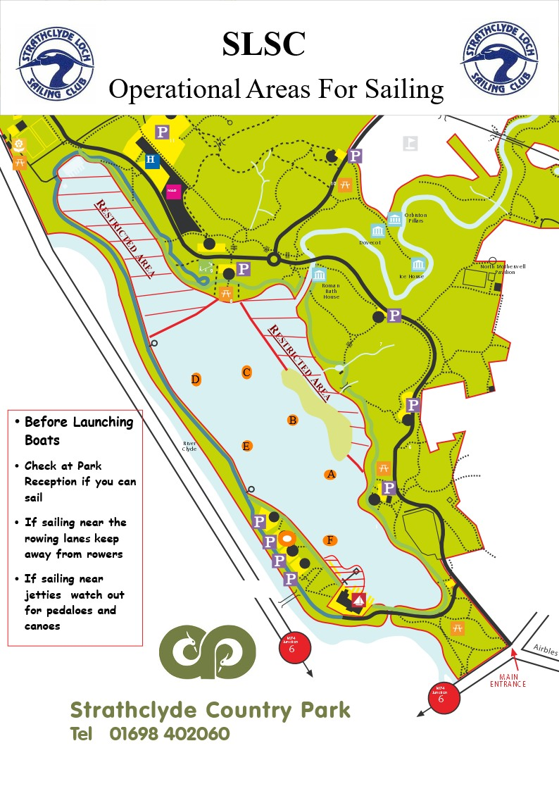
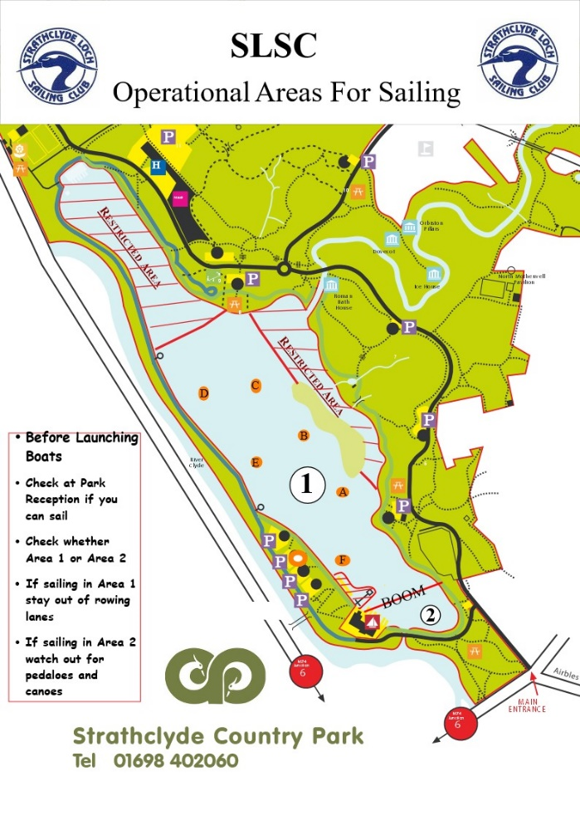
Loch

Water Conditions Flag Good
Water condition forms are available at the park reception and must be filled in each year by all people using the club boats. Later shown as Appendix H
The current water quality in the loch is classed as:
GOOD


- Take care – the water quality is variable across the loch.
- All loch users should wash their hands and their craft after completing their water-based activities.


Water conditions Flag Poor
Water condition forms are available at the park reception and must be filled in each year by all people using the club boats. Later shown as Appendix H
The current water quality in the loch is classed as:
POOR


- Immersion sports (swimming, windsurfing, etc) are currently suspended
- Capsize drill for all water sports currently banned
- If wind is above Force 4 / 13-18mph, qualified or experienced participants only unless under instruction
- It is recommended that all loch users wash their hands after completing your water-based activities.

Positioning of Racing Markers
Race markers and start lines should be places on the shore sides of the rowing lanes leaving enough space for rowers etc to get up and down the loch without infringing on our racing course.

Dealing with a Major Incident

Emergency Action Plan

Instructor
Assess situation/ Head count
Inform Senior Instructor
Inform NLC Safety boat
NLC reception desk or SI to call 999 where needed.

Instructor
Ensure casualty is taken to emergency location: Slipway in front the sailing club.
Ensure the rest of the groups is fully supervised

Principal or duty person ashore
Inform parent or guardian
Update NLC reception desk office
Record in accident book
Review with instructor post incident

Principal Phone number 07708533442

Senior Instructor Phone number:
Stuart 07729149362
Darren 07710267661

Major Incidents Procedure
Should a major incident occur such as entrapment leading to fatality the principal and commodore should be notified as soon as is possible and the RYA guidelines for dealing with a major incident should be followed. These guidelines follow: -

Advice to Principals of RYA Training Centres
These notes give guidelines in the aftermath of a major accident.
- Your priority is the safety of participants and instructors.
- Once ashore you are going to have to deal with the authorities and the press.
- Get a statement from competent witnesses
- Remove the instructor and key witnesses to a place you can talk to them away from the press
- Produce a written statement that you can give to the press
- e.g. SLSC regret to announce the death of a club member who was involved in an incident on Strathclyde Loch, at approximately hh:mm on ddmmyyyy
- Our deepest sympathy to the relatives etc. A full statement will be issued at hh:mm on ddmmyyyy (give yourself time to collate the information).
- Do not hold a press conference
- Decide who will speak to the press// Principal or Commodore?
- Don’t allow well-meaning but ill-informed people to make public comments
- Try to keep a record of whom you have spoken to, who has contacted you etc
- Inform RYA training (023 8060 4181) who can help with compiling your statement to the press
- If the RESUE services have been involved the press will have probably obtained some information from them
- If there has been a fatality the police will contact the Training Centre and inform the next of kin. Do not publicise the name of the casualty until you know this has been done, even if the press appears to know who it is
- Keep any relevant equipment e.g. Lifejackets, logbooks etc
- Major accidents at RYA Training Centres are very rare if you are ever unfortunate enough to be involved in one, it helps if
  - Your paperwork is up to date e.g. you have a contact number for the next of kin
  - Your boats and instructors comply with your own safety policy and the RYA conditions of recognition

Procedures and checklists

Training Centre
Adverse Conditions
Should adverse weather conditions arise whilst on the water, the SI on duty will notify SCP reception desk of proposed action, by contacting safety boat. The SI will ensure all craft and sailors return to the jetty and confirm this with reception desk.

Responsibility
The overall responsibility for safe operation of the RYA RTC is vested in SLSC administrated by the Principal. In the Principal’s absence, the Chief Instructor (CI) may delegate for him/her. The current Principal’s name and names of Chief Instructor are listed on the Training Noticeboard in the Clubhouse adjacent to the Committee Room.

Instructors
Sailing Instructors should hold valid RYA certificates for Dinghy instruction and First Aid. Tuition should be overseen by a qualified Senior Instructor. Assistant instructors should have had relevant training to the role of assistant instructor.
Powerboat Instructors should hold valid certificates for Powerboat instruction and First Aid. Assistant instructors should have had relevant training to the role of assistant powerboat instructor.
Instructors should always carry a knife and a whistle, both easy to hand when going afloat.
Instructors should think carefully before handling awkward or heavy objects, if the manoeuvre cannot be carried out safely and without damage to self then help should be sought. If lifting objects ensure that your feet, knees, back and neck are all lined up before lifting and make sure you bend your knees.

Instructor Ratios

Instructors should ensure that they are not under the influence of alcohol, alcohol should not have been consumed for at least 8 hours prior to teaching.
Instructors should have completed a Disclosure Scotland check prior to teaching at SLSC. Disclosure Scotland
Instructors should have read and understood the club’s policy on child protection and where ever possible have attended a child protection awareness session prior to teaching at SLSC,
It is an instructor’s responsibility to count the number of boats/participants in his/her group on launching and recovery to ensure that everyone is accounted for.
Student: Instructor Ratios should always be observed for all courses at all levels.

Type of Craft | Student: instructor Ratio
Crewed Dinghies | 3:1 for beginners with instructor onboard  Maximum 9:1 but not more than 6 boats per instructor (e.g. 3 Wayfarers with 3 students in each, or 4 Picos with 2 students in each)
Single handed dinghies | 6:1 (applies only whilst the boats are used as single-handers)
Powerboats | Levels 1 and 2 - 3:1  All others – 6:1 (2 boats)
Instructors may be assisted by unqualified helpers who are competent and experienced. They should be supervised by an instructor or SI and deployed in roles appropriate to their skills and awareness.
An assistant instructor counts as qualified in the following ratios and should work under the direction or supervision of an instructor or SI.

Safety Boat Ratios for Dinghy Sailing tuition

Activity | Safety Boats
Dinghies (single handed or crewed) | Up to 6 dinghies 1 safety boat  7 to 15 dinghies 2 safety boats  More than 15 dinghies 3 or more safety boats

Inversions leading to entrapment
If a boat is fully inverted, the priority is to ensure that all bodies are accounted for, if they are not then the RYA recommended method is for a member of the safety boat crew to help right the boat by standing on the gunwale of the boat to assist in righting it. Tests have proven that this is the fastest way to right a boat that is fully inverted. All club boats upon which trapezing is taking place shall be fitted with masthead flotation devices to avoid a total inversion capsize. Where club boats are being used with trapezes, rib crews will be briefed about the dangers of entrapment.

Committee Boat and Safety Boat refuelling Procedure
There should be no smoking or use of mobile phones or other sources of ignition whilst near the fuel store. Fuel purchasing is normally organised by the Bosun and is stored in the container (max 10L). The red outboard fuel tanks are normally kept in the boats and must be removed from boat before filling or replacing. Tank to tank transfers are to be made outside the storage container using a filter funnel and using safety goggles and gloves provided.

Training Boats Rigging / Launching and Recovery
Training boats are stored within the SLSC compound area. The CI will inspect each boat prior to rigging and launch from SLSC jetties. Should there be any issue which cannot be fixed by the instructor the boat will be withdrawn from service until repaired. The issue must be logged in the boat maintenance sheet, included in the Asset and Maintenance Register. This can be found on the administration desk in the Committee Room. Masts (Laser and Pico), sails, rudders and centre boards are stacked in the racking in the storage container. Each piece of equipment is labelled with the SLSC identity number, to match the boat number shown in the Asset Maintenance Register. This can be found on the administration desk in the Committee Room.

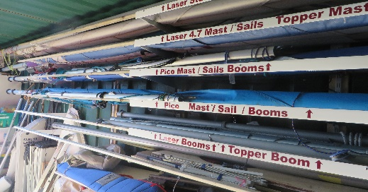
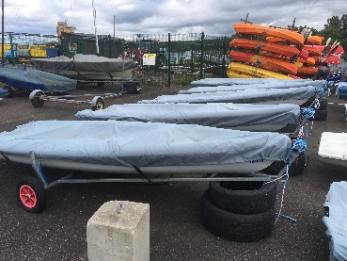
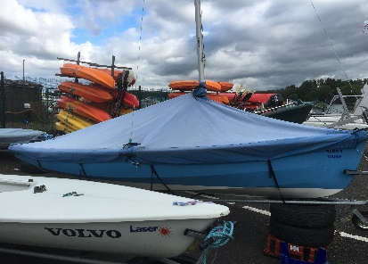

SI must ensure rigging has been safely completed before the boat is made available for use. See Rigging Manual and Launch Procedure Instructions.
The SI must ensure there are enough participants available to safely transport and launch the boat from the jetty or foreshore. When sailing multiple single-handed boats, the SI must be confident that all participants are capable of manoeuvring safely immediately offshore until the group are ready to set off on the day’s activities.
Recovery, the SI must ensure a presence on the jetty or foreshore to help with recovery. Whilst sailing multiple single-handed boats the SI may decide the order of recovery, taking account of individuals ability and weather conditions.
Each boat should be returned to its designated location. The crew must make the SI and/or Bosun aware of any damage or relevant issues for repair. The details must be recorded in the boat maintenance sheet included in the Asset Register in the Committee Room.

Club Safety Boat Launch/ Recovery Procedure
- Collect Rib bag from committee room
- Collect engine key and kill cord from committee room key safe
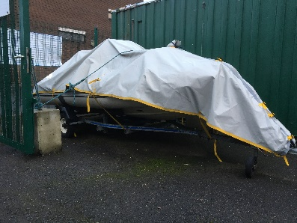
- Boat located beside green container

- Remove boat cover and wheel lock
- Check boat
        - Both bungs are in
        - Check fuel if fuel required remove red fuel container from boat and fill using fuel that is located in container
        - Do not fill inside container or boat
        - Replace fuel containers and reconnect fuel tank to boat
        - Check outboard is engine is raised
        - Put grab bag and key in boat
        - Boat can now be taken to slip area.
        - At top of slip area undo boat painter and trolley recovery rope and winch
        - Decide on slip to be used
        - This operation requires 2 persons with buoyancy aids on
        - One person takes painter must have buoyancy aid
        - One person gets ready to push boat down slip
        - Watch out for slip being greasy
        - Check rear of boat is clear
        - Check slip is clear
        - Look out for people walking / cyclists in area
        - If all clear push boat down slip
        - Person on painter can pull boat off trailer and tie boat to jetty
        - Remove trailer from water and pull trailer up against compound fence or back into Dinghy compound
      - Rib is now ready to be started and maned (buoyancy aids essential for all)
        - Check no water coming into boat
        - Lower engine and lock down
        - Check fuel is on and tank vent open pump fuel through if necessary
        - Put key in control switch
        - Check for neutral
        - Connect kill cord
        - Start engine
        - Check for engine cooling water
- Boat is now ready to use

      - Boat recovery procedure
        - Switch off engine
        - Remove kill cord
        - Switch off fuel
        - Tilt engine
        - Put launch trolley in water with one person holding recovery rope
        - Pull rib onto trolley and connect winch clip
        - Make sure that there is adequate personnel to pull boat up slope of slipway (min 2 adults)
        - Check if boat needs cleaned. Buckets and Sponges in container
        - Pull boat back into compound and put cover on boat
        - Put grab bag and key back in committee room
      - Report any problems in assets book

Committee Boat Launch Procedure
- Collect Committee bag from committee room
- Collect engine key and kill cord from committee room key safe
- Boat located in compound
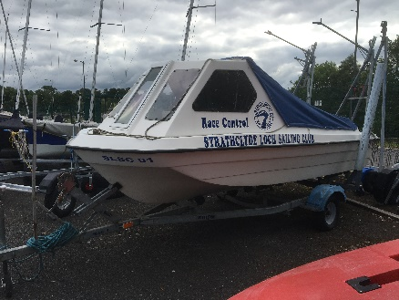

- Remove blue boat cover
- Check boat
        - Bungs is in
        - Check fuel if fuel required remove red fuel container from boat and fill using fuel that is located in container
        - Do not fill inside container or boat
        - Replace fuel containers and reconnect fuel tank to boat
        - Check outboard is engine is raised
        - Put grab bag and key in boat
        - Check for Flags
        - Insert Flag Pole and check horn is connected
      - Boat can now be taken to slip area
      - Move boat with 5 persons minimum
      - Move boat to top of selected slip
      - Undo painter and trolley recovery rope
      - At top of slip unclip rear ropes, undo from pipes and reclip to boat
      - Make sure area behind boat is clear
      - Look out for people walking / cyclists in area
      - edge
      - Be aware of greasy slip
      - Remove winch connection to boat
      - Person to hold painter must be wearing buoyancy aid
      - Run boat into water and tie to jetty using painter and rear rope
      - Pull trolley out of water and store in compound
      - Committee boat is now ready to be started and manned, buoyancy aids are essential for all
      - Check no water coming into boat
      - Lower engine
Collisions / Near misses
As standard practice crews must be observant of other craft on the Loch. Rowing Clubs have priority use from 8:00 am – 10:00 am on Sunday but may be on the water later than this. Special care must be taken using area 2 as this is used by less experienced public on pleasure boats.
Should there be a situation which could be regarded as a near-miss, the details must be recorded in the Accident and Collison Register. This will be addressed by the principal on a regular basis and appropriate action taken.

Park Safety Boats
SCP provide safety boats and carry the following essentials

- Radio in working order
- There is enough fuel for the session and fuel tank is secured
- Fire Extinguisher
- First Aid kit
- Safety knife
- An anchor and warp attached to the boat
- Tow line
- Throw Line
- A kill cord is attached to the boat
- A spare kill cord
- Paddle
- Bailer / Bucket
- Tool kit
- Survival Bag / Blanket
- Sailing Area Picture

Training Rib / Club Safety Boat Kit List
SLSC has its own safety boat. The Grab bag is stored in the Admin Area. Ensure all contents available
- Fuel Container already in boat (Check if fuel required and remove Fuel Tank from boat before filling)
- Paddle already in boat
- Anchor already in boat
- Fire Extinguisher already in boat
- Bucket / Bailer already in boat
- Radio if required
- Control Key Marked Rib in main key cupboard

Grab bag containing:
- Survival Blanket
- First Aid Kit includes disposable gloves face masks and sanitiser
- Throw Line bag
- Tow Line// minimum four metres
- Sharp serrated knife
- Tool Kit
- Spare key and kill cord (do not use as main key)
- Emergency Action Plan
- Loch Sailing Areas Sheet
- Grab Bag contents List

Index of Appendices

Index of Appendices
Appendix A Risk Assessment 25
Appendix B1 Sailing Area Without Boom 26
Appendix B2 Sailing Areas With BOOM 27
Appendix C 1 Adult Course booking Form Dinghy 28
Appendix C cont’d Training Record 29
Appendix C2 Power Boat COURSE BOOKING FORM 30
Appendix C3 Junior Dinghy Form (for participants under 17 years) 31
Appendix C4 Junior Course Booking Form Powerboat 32
Appendix D Day Membership / Taster Form Adult 33
Appendix E Day Membership / Taster Form Junior Sailing Parental Consent Form 34
Appendix F Sailing Sign Out Sheet 35
Appendix G Race control sheet 36
Appendix H Water Conditions Form 37
Appendix I.1 Water Conditions Good Flag 38
Appendix I2 Water conditions Flag Poor 39
Appendix J INCIDENT / ACCIDENT REPORT FORM 40
Appendix K Collision Form 41
Appendix L1 Safety Boat KIT LIST / CHECK LIST 42
Appendix L2 COMMITTEE BOAT KIT LIST / CHECK LIST 43
Appendix M1 Briefing Sheets 44
Appendix M2 Instructors Morning Info Sheet 45
Appendix N Instructor Qualifications Sheet 46
Appendix O Introduction / Courses/ Cancellation/ Feedback 47
Appendix P Club Constitution (removed see website) 50
Appendix Q Child Well-Being and Protection Policy 51
Appendix R Health and Safety Policy 25th March 2021 52
Appendix S Club Abandoned Boats Policy March 25 55
Appendix T RYA Course Certificate Master 57
Appendix U Sign off and release for operational use 58

Appendix A Risk Assessment

Hazard | Who is involved | Control | Information/action
Drowning | Students  Instructor  Support Staff | Buoyancy aids always on water and jetties  Qualified Instructors  Small staff/pupil ratios  Emergency/First Aid  Students to be water confident | Pre – visit information  Operating Procedures  Introductory talk  RYA guidelines
Entrapment | Students  Instructor  Support Staff | Mast Head floats  Qualified Instructors  Safety Boats  Knife as part of Instructor kit | Instructor talk  Instructor Supervision  RYA guidelines
Cold | Students  Instructor  Support Staff | Kit list issued prior to visit  Qualified Instructors  Appropriate clothing  Access to shelter/warmth  When clubhouse closed | Pre – visit information  Operating Procedures  Introductory talk  RYA guidelines
Sun/Heat | Students  Instructor  Support Staff | Kit list issued prior to visit  Qualified Instructors  Instructor monitors group  Cool off sessions/access to bottled drinking water on shore | Pre – visit information  Operating Procedures  Introductory talk  RYA guidelines
Health/Ailments | Students  Instructor  Support Staff | Pre-Course health declaration  Onsite first aid and emergency systems  First aid kit on RIB and Clubhouse /Defibulator at Park Counter | Pre – visit information  Operating Procedures  Introductory talk
Physical Injury | Students  Instructor  Support Staff  Public | Quality equipment and maintenance systems  Storage systems with health warnings | Operating Procedures  Introductory talk  RYA guidelines
Slips/trips and falls | Students  Instructor | Kit list references footwear  Awareness and removal of slime on jetties - NLC | Operating Procedures
Slipway hazards | Students  Instructor  Support Staff | Clear briefings  Nobody behind wheels when launching | Instructor supervision
Stacking Boats | Students  Instructor  Support Staff | Clear briefings  Minimum of 3 adults  Awareness of other compound users | Introductory talk  Instructor supervision
Water Quality | Students  Instructor  Support Staff | Clear briefing  Awareness of Flags  Capsize risk | Introductory Talk and Compulsory Form App H  Wash Hands  Shower after Capsize
Head Injury | Students  Instructor  Support Staff | Helmets worn in appropriate conditions at discretion of SI | Talk about boom incidents and precautions

Appendix B1 Sailing Area Without Boom

Appendix B2 Sailing Areas With BOOM

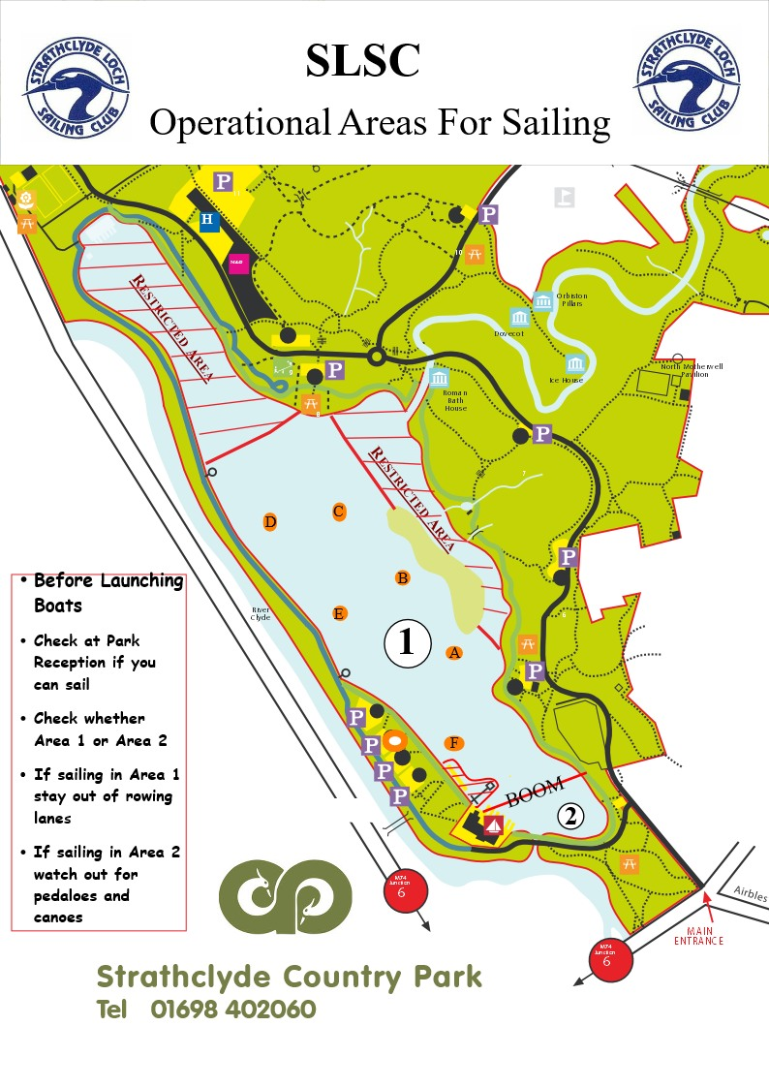
Appendix C 1 Adult Course booking Form Dinghy

Full Name:

Occupation: | Membership Number
Address:

Post Code:
Telephone Number: | Home: | Work: | Mobile:
Contact e-mail address:

RYA Course Details

Course Name: | Cost  RYA Level £
Course Start Date: |  | Course Finish Date:

Medical Information

Please state any medical conditions & medication required: Including any symptoms

Disability Information

Do you have any special requirements relating to a personal disability and is there ways we can support you on and off the water ? | Yes: No:
If yes, please detail:

Emergency Contact (Name, Address, Contact Number)

I am hereby acknowledging that all the information above is correct and I am medically fit to participate in the relevant RYA course.
My personal details may be used by SLSC solely for Club Activities.
Consent For Use of Images
I agree
I disagree
Images taken during the course to be used for SLSC Club Activities

SLSC fulfils its obligations under General Data Protection Regulations (25 May 2018).

Signed: Date:

Appendix C cont’d Training Record
Date | Wind L/M/H | Training Stage | Comments / Areas to work on | Instruction

Appendix C2 Power Boat COURSE BOOKING FORM

Full Name:

Occupation: | Membership Number
Address:

Post Code:
Telephone Number: | Home: | Work: |  | Mobile:
Contact e-mail address: |  |  | Date of birth

RYA Course Details

Course Name: | Cost  RYA Powerboat 2 Course £
Course Start Date: |  | Course Finish Date:  Srcond Date

Medical Information

Please state any medical conditions & medication required: Including any symptoms

Disability Information

Do you have any special requirements relating to a personal disability and is there ways we can support you on and off the water ? | Yes: No:
If yes, please detail:

Emergency Contact (Name, Address, Contact Number)

I am hereby acknowledging that all the information above is correct and I am medically fit to participate in the relevant RYA course.
My personal details may be used by SLSC solely for Club Activities.
Consent For Use of Images
I agree
I disagree
Images taken during the course to be used for SLSC Club Activities

SLSC fulfils its obligations under General Data Protection Regulations (25 May 2018).

Signed: Date:

Appendix C3 Junior Dinghy Form (for participants under 17 years)

Course | Youth Sailing 2026 Stages 1 to 4  6 Lesson block to be completed by 8 weeks after start date
Start Date
Cost £ 0 per block | Payable to Strathclyde Loch Sailing Club. Sort Code 80-17-02 Account no 00109928

Participants Details
Full Name
Home Address
Date of Birth |  | Age

Parent / Guardian / Person with legal responsibility
First Name |  | Surname
Relationship to Youth |  | Phone No |  | Email

Emergency Contact
First Name |  | Surname
Relationship to Child |  | Contact No during Session

Medical Information
It is your responsibility to make known any disability / medical condition that may affect your child during the activity, and any
medication that they may require.
Has your child ever suffered from any of the following conditions  Asthma / bronchitis, heart condition, fits, fainting or blackouts, severe headaches, diabetes? |  | Yes | No
Is your child currently taking any medication | If yes please specify
When did your child last have a tetanus injection | Year
Is your child suffering/recovering from any injuries that may affect their sailing | If yes please provide details
Does your child have any food allergies | If yes please provide details

Does your child have any disabilities, learning difficulties or medical condition which may affect their learning | Yes | No | If yes please specify

Medical Consent
I give permission during the period of the event as above to administer any relevant treatment or medication to the above named participant when or if necessary.
In an emergency I authorise the organisers to take my child to hospital. I understand that I shall be notified as soon as possible, of the hospital visit and any treatment given by the hospital.
Consent for use of images
I agree
I disagree
Images taken during the activities can be used for publicity by Strathclyde Loch Sailing Club

Signed (Parent or Guardian) |  | Print Name

Appendix C4 Junior Course Booking Form Powerboat

Course | Powerboat 1 or 2
Start Date
Cost £ 0 | Payable to Strathclyde Loch Sailing Club. Sort Code 80-17-02 Account no 00109928

Participants Details
Full Name
Home Address
Date of Birth |  | Age

Parent / Guardian / Person with legal responsibility
First Name |  | Surname
Relationship to Youth |  | Phone No |  | Email

Emergency Contact
First Name |  | Surname
Relationship to Child |  | Contact No during Session

Medical Information
It is your responsibility to make known any disability / medical condition that may affect your child during the activity, and any
medication that they may require.
Has your child ever suffered from any of the following conditions  Asthma / bronchitis, heart condition, fits, fainting or blackouts, severe headaches, diabetes? |  | Yes | No
Is your child currently taking any medication | If yes please specify
When did your child last have a tetanus injection | Year
Is your child suffering/recovering from any injuries that may affect their sailing | If yes please provide details
Does your child have any food allergies | If yes please provide details

Does your child have any disabilities, learning difficulties or medical condition which may affect their learning | Yes | No | If yes please specify

Medical Consent
I give permission during the period of the event as above to administer any relevant treatment or medication to the above named participant when or if necessary.
In an emergency I authorise the organisers to take my child to hospital. I understand that I shall be notified as soon as possible, of the hospital visit and any treatment given by the hospital.
Consent for use of images
I agree
I disagree
Images taken during the activities can be used for publicity by Strathclyde Loch Sailing Club

Signed (Parent or Guardian) |  | Print Name

Appendix D Day Membership / Taster Form Adult

Name

Address

Post Code | Contact Phone No

Email

Emergency Contact | Phone No

Day Membership entitles the holder to full membership privileges of SLSC on the
day for which it is issued. The day membership is not free and charges are
applicable e.g. water fees, coaching fees etc.. The member must agree
to abide by the articles of the club constitution.

I am hereby acknowledging that all the above information above is correct, and above is medically fit to participate in the relevant RYA activity

My personal details may be used by the SLSC solely for Club Activities
I Agree
I Disagree
Consent For Use of Images

Images taken during the activity to be used for SLSC Club Activities

SLSC fulfils its obligations under the General Data Protection Registrations (25 May 2018)

Signature of Applicant …………………………………………….

Date ………………..

Signed for SLSC …………………………………………………………………
Appendix E Day Membership / Taster Form Junior Sailing Parental Consent Form

Name | Age

Name | Age

Name | Age

Parents Name

Address

Post Code | Contact Phone No

Email

Day Membership entitles the holder to full membership privileges of SLSC on the
day for which it is issued. The day membership is not free and charges are
applicable e.g. water fees, coaching fees etc.. The member must agree
to abide by the articles of the club constitution.

I am hereby acknowledging that all the above information above is correct, and above juniors are medically fit to participate in the relevant RYA activity

My personal details may be used by the SLSC solely for Club Activities
I Agree
I Disagree
Consent For Use of Images

Images taken during the activity to be used for SLSC Club Activities

SLSC fulfils its obligations under the General Data Protection Registrations (25 May 2018)

Signature of Parent / Guardian …………………………………………….

Date ………………..

Signed for SLSC …………………………………………………………………
Appendix F Sailing Sign Out Sheet


Strathclyde Country Park
Sailing Club Sign Out Sheet
Club Name
Coach Name
Date

Please complete in BLOCK CAPITALS
Name(s) | Membership Number | SESSION  (Please tick session) |  |  | Please tick for Juniors
 |  | Morning | Afternoon | Evening

Appendix G Race control sheet

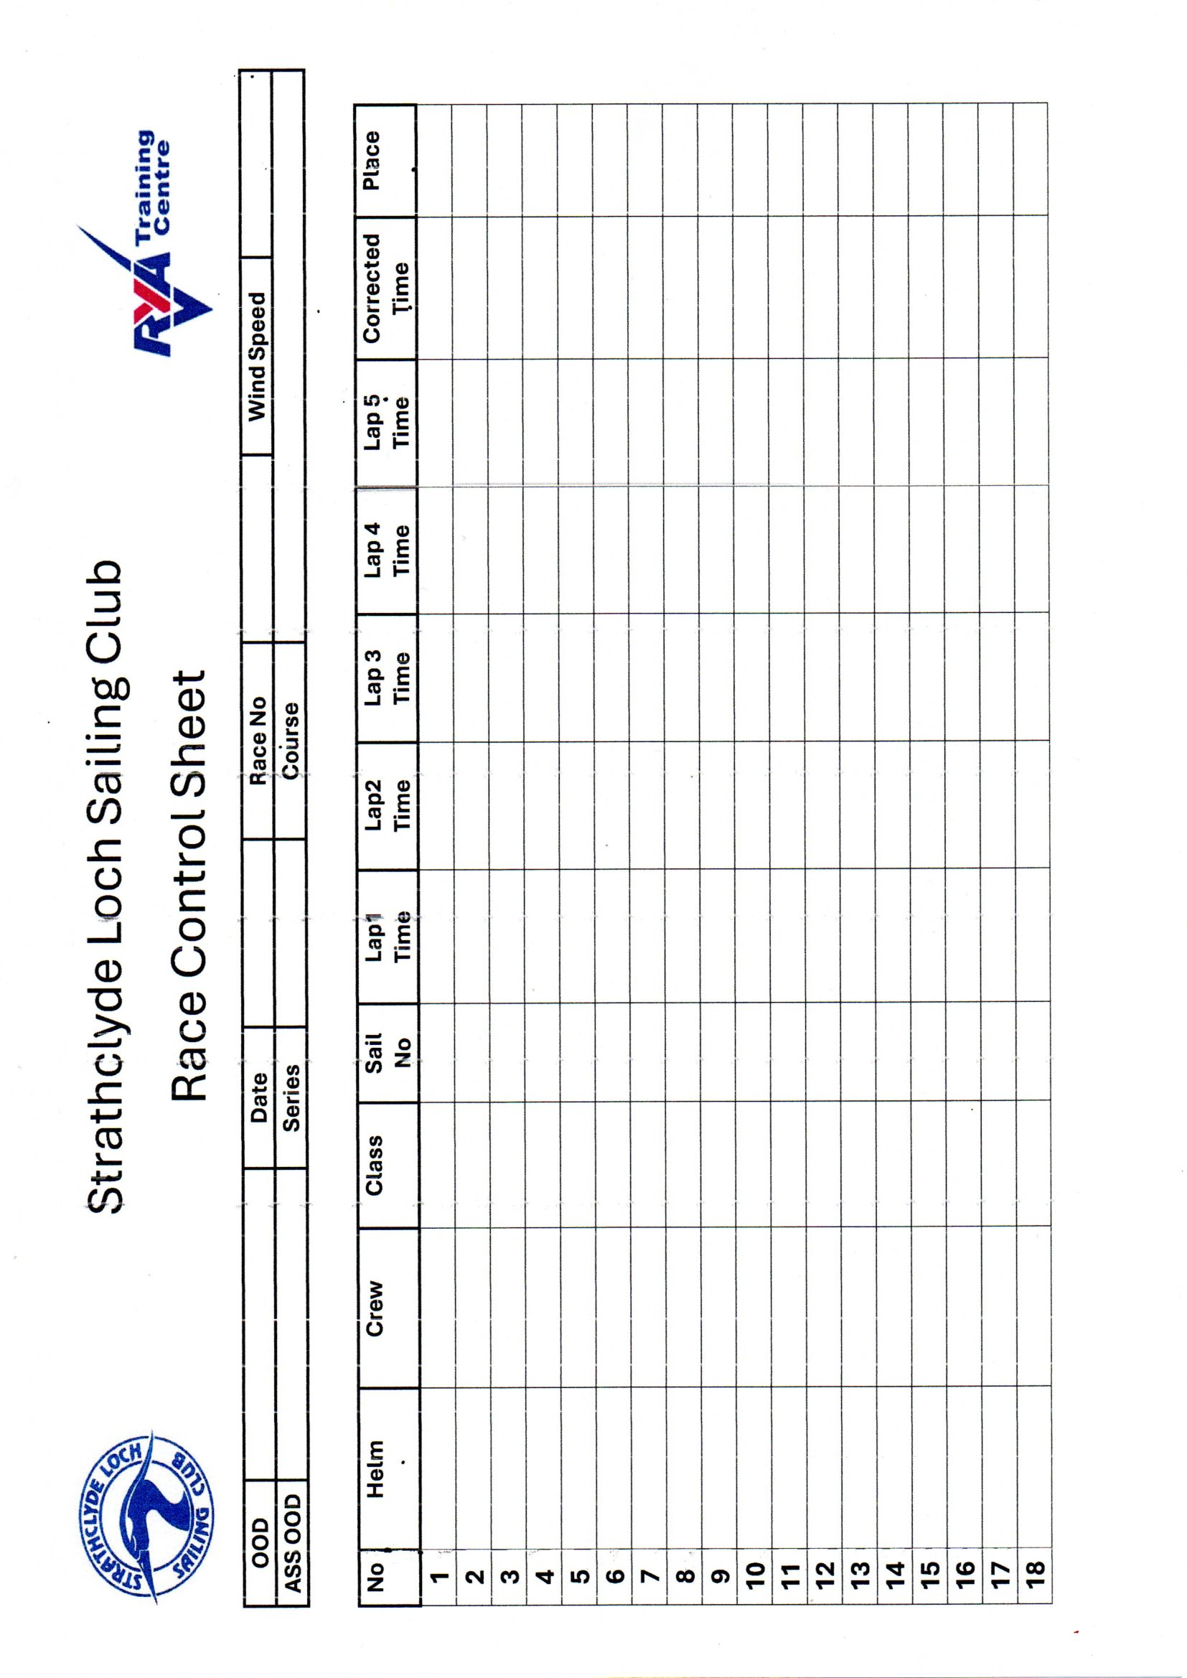
Appendix H Water Conditions Form

Water condition forms are available at the park reception and must be filled in each year by all people using the club boats
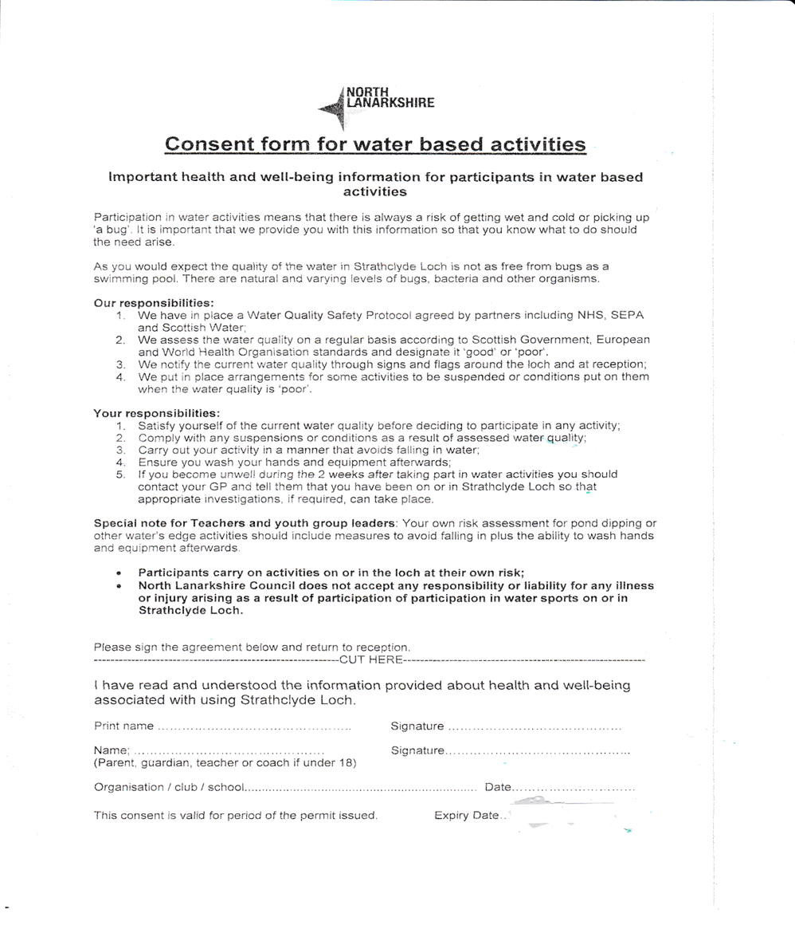

Appendix I.1 Water Conditions Good Flag

The current water quality in the loch is classed as:
GOOD
- Take care – the water quality is variable across the loch.
- All loch users should wash their hands and their craft after completing their water-based activities.

Appendix I2 Water conditions Flag Poor

The current water quality in the loch is classed as:
POOR
- Immersion sports (swimming, windsurfing, etc) are currently suspended
- Capsize drill for all water sports currently banned
- If wind is above Force 4 / 13-18mph, qualified or experienced participants only unless under instruction
- It is recommended that all loch users wash their hands after completing your water-based activities.

Appendix J INCIDENT / ACCIDENT REPORT FORM

Name of Session | Person in Charge | Date

Site of Incident / Accident and details of what activity was taking place

Name and Address of injured person

Nature of incident / injury and extent of injury and First aid Treatment
First Aiders Name

Were any of the following present or contacted
Parents / Carers | yes | no
Police | yes | no
Ambulance | yes | no

What happened to injured person following accident

Name of person in charge | Signature | Date

Appendix K Collision Form

Name of Session | Person in Charge | Date

Site of Collision and details of what activity was taking place (drawing)

Name and Address of persons involved and phone numbers

Details of Damage (take pictures if possible)

Name of person in charge | Signature | Date

Appendix L1 Safety Boat KIT LIST / CHECK LIST

- Fuel Container already in boat (Check if fuel required and remove Fuel Tank from boat before filling)
- Paddle already in boat
- Anchor already in boat
- Fire Extinguisher already in boat
- Bucket / Bailer already in boat
- Radio (if being used as Safety Boat)
- Control Key Marked Rib in main key cupboard

Grab bag containing:
- Survival Blanket
- First Aid Kit, disposable gloves, face masks and sanitiser
- Throw Line bag
- Tow Line// minimum 4 metre
- Sharp serrated knife
- Tool Kit
- Spare key and kill cord (do not use as main key)
- Emergency Action Plan
- Sailing Area Picture
- Grab Bag contents List

Please collect and return items to the club house and remember to leave boat clean and tidy

Appendix L2 COMMITTEE BOAT KIT LIST / CHECK LIST

- Control key marked Committee boat (in main key cupboard)
- Fuel Container already in boat (Check if fuel required and remove Fuel Tank from boat before filling)
- Paddle already in boat
- Anchor already in boat
    - Fire Extinguisher already in boat
    - Kit in boat cupboard in front of controls
      - Survival Blanket
      - First Aid Ki disposable gloves, face masks and sanitiser
      - Throw Line bag
      - Tow Line// minimum 4 metres
      - Sharp serrated knife
      - Tool kit
      - Bailer (boat has electric pump)

    - Committee Boat Grab Bag
      - OOD folder
      - Race Sheets
      - Pencil / Pens
      - 2 Timers
      - Calculator
      - Spare key and kill cord (do not use as main key)
      - Emergency Action Plan
      - Grab Bag Contents List

Remember to take Race Buoys for Start Line and Markers

Please collect and return items to the club house and remember to leave boat clean and tidy

Appendix M1 Briefing Sheets

Instructor Briefing Sheet
- Loch Sailing Areas Available
- Other Loch users in Sailing Area
- Weather / Wind Conditions
- Type / Age of Trainees and any known problems
- Club Boats available
- Hand / Whistle Signals being used
- Ensure all Trainees have completed Course Form and Water Conditions Form Appendix H
- Remind Trainees on social distance requirements

Trainee Briefing Sheet
- Compound hazards (ropes cement blocks, tractor etc)
- Swimming Ability / Confident in water
- Medical Conditions
- Sailing Areas and hazards
- Proper clothing for conditions
- Falling overboard / Capsize / Boom and head injuries
- Hand /Whistle Signals being used
- Ensure all buoyancy aids checked before going on slip or water
- Remind Trainees on social distance requirements
- Wash / Sanitize hands after coming off water

Appendix M2 Instructors Morning Info Sheet

Date …………………. Instructor …………………………

Weather and wind strength : ………………….. Water Conditions …………………..

Anything of note from previous session

Groups in today :

Name | Phone Number | AM | PM

Groups / Instruction / Boats

Anything of note for following session

Appendix N Instructor Qualifications Sheet

Appendix O Introduction / Courses/ Cancellation/ Feedback

Introduction to Sail Training at Strathclyde Loch Sailing Club

Background
You are about to undertake a series of lessons under the guidance of a qualified Royal Yachting Association (RYA) instructor. SLSC can provide training for Youths and Adults using our own boats.

There are several levels within the National Sailing Scheme. Each level can be completed in two full days or in flexible sessions with min of 8 hours water time. Progress will be recorded in your personal Scheme Syllabus & Logbook. There may be a charge for lessons and the Log Book.

Youth Beginners’ Course guidance

Course | Assumed Knowledge | Course Content | Ability after the course
Stage 1 | None | Launching and recovery, steering, parts of the boat, basic sailing | Able to steer and understand basic principles
Stage 2 | Basic knowledge and steering ability to Stage 1 standard | Basic sailing skills, ropework, collision avoidance | Able to tack and control boat speed and understand basic principles
Stage 3 | Up to and including Stage 2 standard | Rigging, launching and recovery, sailing techniques, capsize recovery, sailing theory | Able to launch and sail a dinghy around a triangle in moderate conditions
Stage 4 | Up to and including Stage 3 standard | Launching and returning to a beach, jetty or mooring, and sailing a crewed dinghy around a triangle in moderate conditions | Able to launch and sails a dinghy around a triangle in moderate conditions

Adult Beginner’s Course Guidance

Course | Assumed Knowledge | Course Content | Ability after the course
Level 1 Introducing you to sailing with all you need to know to get afloat under supervision | None | How to sail in all directions, including an awareness of launching and recovery | Able to sail in light windows under supervision
Level 2 Setting out the foundations of sailing for you | Sailing skills to the standard of Level 1 | Rigging, launching, sailing in all directions. Capsize recovery and essential safety knowledge | Able to sail and make decisions in good conditions
Level 3 Consolidating skills and trying new ones | Sailing skills to the standard of level 2 | Rigging, launching and recovery, sailing techniques, capsize recovery, sailing theory | More confident in sailing skills and techniques, and ready to progress onto advanced modules

Other Courses
The Club can also provide other courses eg Powerboat level 1&2

Training Plan
The Senior Instructor will discuss your requirements and develop lesson plans. The course includes sailing theory as well practical work on the water. The objective is to ensure you complete all parts of the Syllabus. The Senior Instructor will provide feedback as you complete each lesson. Progress will be recorded in your Log book

Candidate Responsibility
Courses must be booked in advance through the Club Training email training@strathclydelochsailing.com or mobile 07899942822. You must inform the principal or senior instructor, mobile 07899942822 if you are unable to attend a booking.
We may have to cancel/reschedule sessions dependent on weather conditions. Principal or Senior Instructor will contact candidates by phone/text or email,

Students should aim to arrive at least 10 minutes before the expected start time. This gives time to complete any administration. Equally to ensure the candidates are in full kit able to start the lesson. Failure to arrive in time is unfair to other participants. You may not be able to join the lesson that day.
Failure to attend without prior notice may be deducted from your quota of lessons.

Cancellation or withdrawing from a course
Refunds for cancelling or withdrawing from a course will be at the discretion of the Principal

Completion of Training
If, in the opinion of the Senior Instructor, you can successfully demonstrate the full range of capabilities you may be issued with the appropriate certificate e.g. RYA Level 1 or Level 2 Dinghy Certificate. You should keep this safe as the RYA is not able to provide a replacement certificate.

Course Evaluation Sheet
Candidates we be invited to complete a course evaluation sheet. Your opinions are important to help monitor the Club’s performance and help further development of future modules.

Course Evaluation Sheet

Course | Start date | End date | Instructor

Q1 | Did you complete the Course? Yes/No

Q2 | Did it meet your expectations? Yes/No

Q3 | Overall was the duration correct? Yes/No

Q4 | Did you have any problems with practical issues? Yes/No

Q5 | Do you have any suggestions on how we might improve the course?

Appendix P Club Constitution (removed see website)

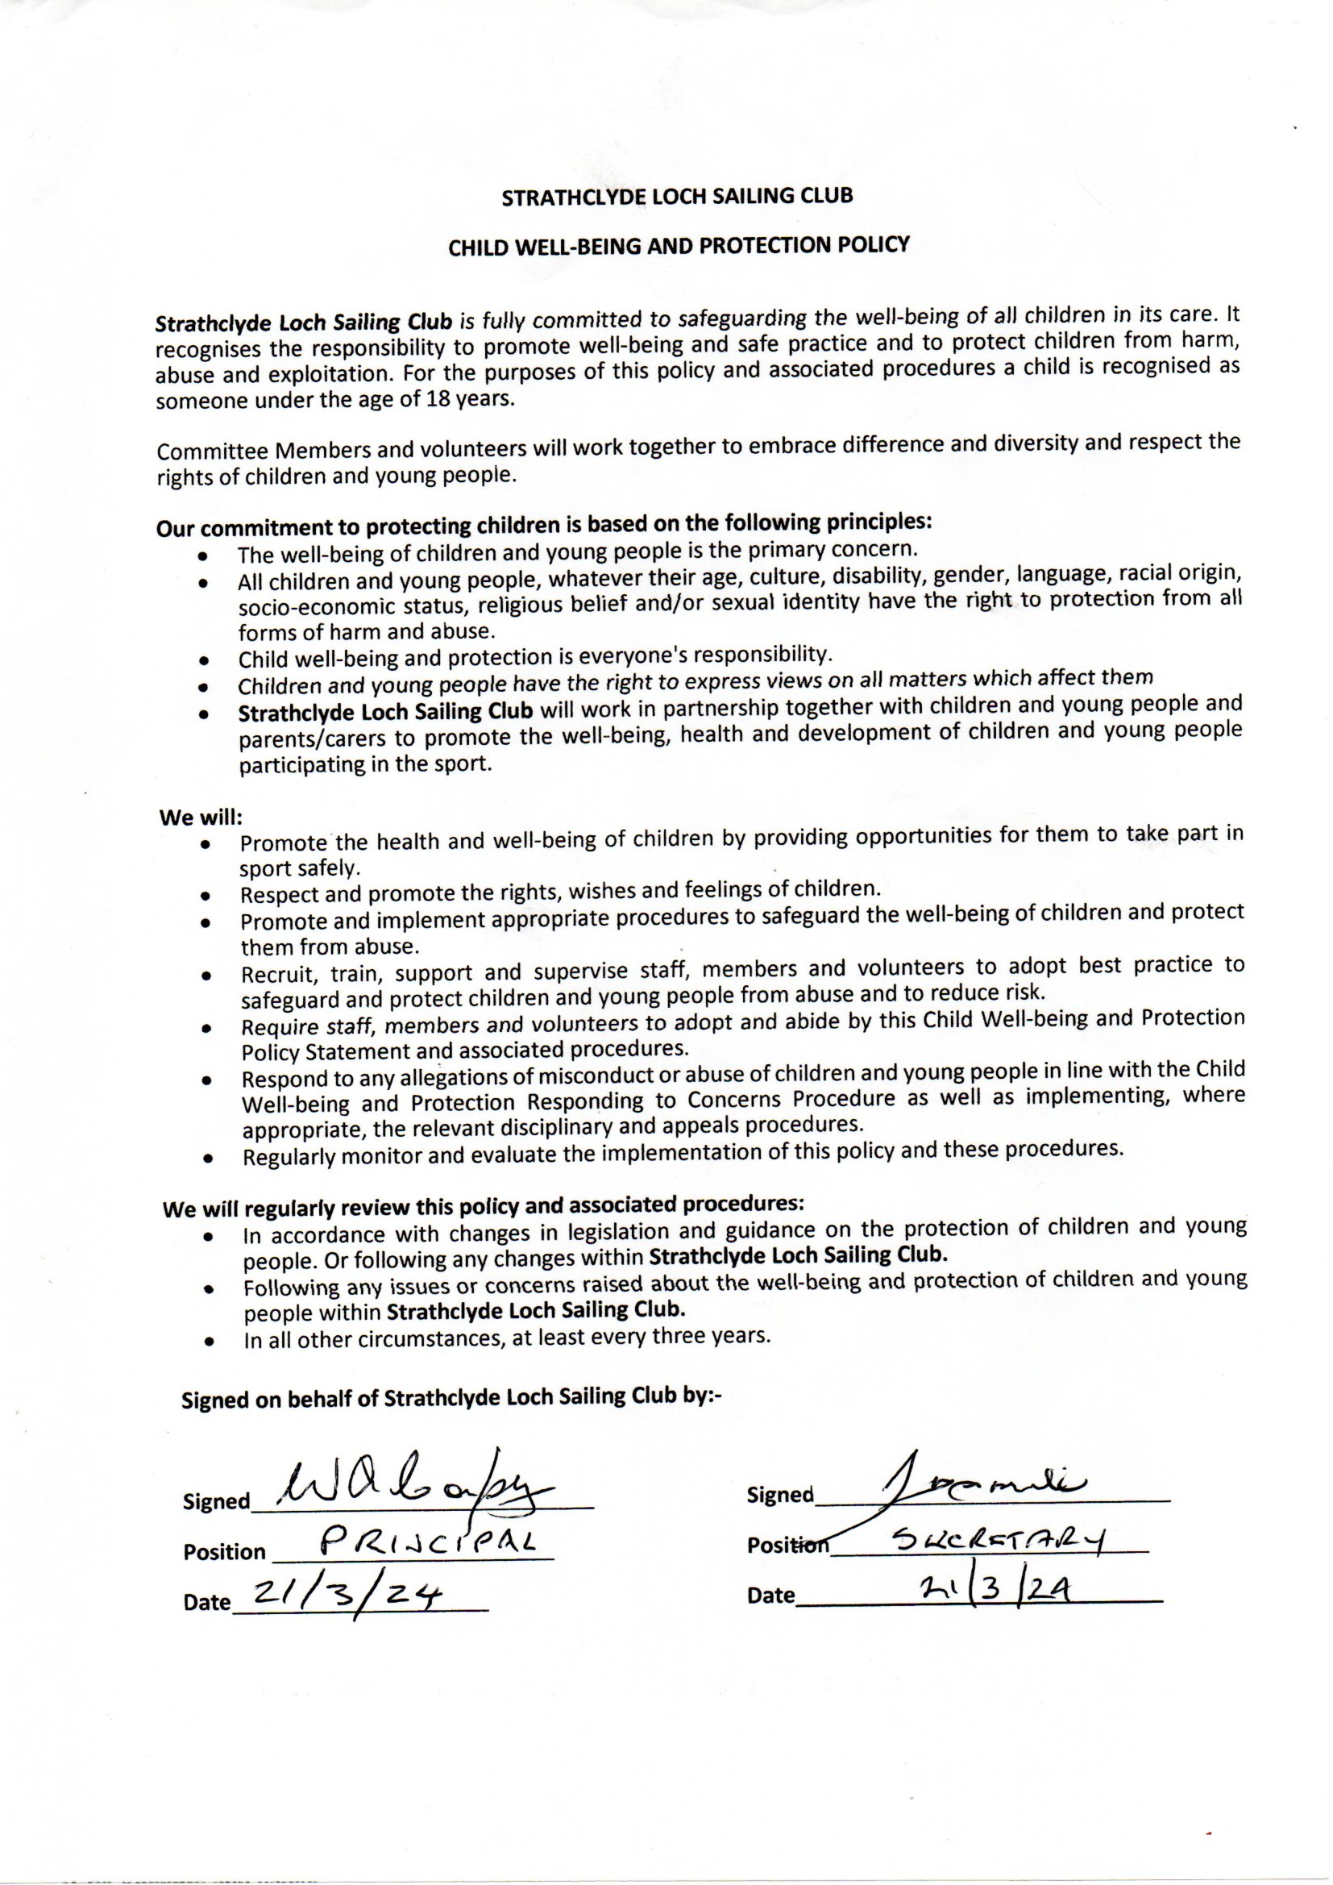
Appendix Q Child Well-Being and Protection Policy

Appendix R Health and Safety Policy 25th March 2021
HEALTH & SAFETY POLICY

POLICY STATEMENT
Strathclyde Loch Sailing Club attaches great importance to the health and safety of its members and all members of the public using facilities provided by us. To this end the organisation aims to ensure that all activities carried out or undertaken by its members in relation to the work of the organisation, are managed in such a manner to avoid, reduce or control all foreseeable risks to the health and safety of any person(s) who may be affected by such activities to a tolerable level.
Strathclyde Loch Sailing Club will adopt and implement procedures that are compatible with and recognise the duties imposed by the provisions laid out in the Health & Safety at Work Act 1974. The organisation will pay particular attention to the provision of:
- A healthy working environment
- Safe and suitable resources and equipment
- Sufficient training for members to ensure their ability to comply with health & safety regulations and procedures
- First-Aid kits are located in the clubhouse, RIB and Committee Boat.
- Risk Assessments for all aspects of work carried out by the organisation,

POLICY PROCEDURES
General Duties of all Members
- To take reasonable care to avoid acts or omissions that may adversely affect the health and
safety of yourself and others
- To co-operate fully with anyone responsible for carrying out health and safety checks
- To not intentionally or recklessly interfere with, or misuse, any resource or equipment provided for health, safety or welfare
- To observe health and safety procedures.
- Operating procedures are available in the Standard Operating Procedure which can be viewed in clubhouse and website www.strathclydelochsailing.com
- The club’s Child Protection policy is available in the clubhouse and can be obtained from welfare officer at safeguard@strathclydelochsailing.com
- Covid Procedures and guidance can be viewed in clubhouse and in website membership area in www.strathclydelochsailing.com

Reporting of Accidents or Incidents
- The primary purpose of reporting accidents and incidents is to identify the underlying
cause(s) of the accident or incident and any contributing factors, in order to prevent further similar occurrences. All members are required to report all accidents and incidents using the correct reporting form SOP Appendix E and are kept in Accident Register in clubhouse

- If an accident or incident is reportable to the Health and Safety Executive as required by the
Reporting of Injuries, Diseases and Dangerous Occurrences Regulations (RIDDOR) or Control of Substances Hazardous to Health (COSHH) is of a sufficiently serious nature, then the Commodore, or in his/her absence Committee Member, will ensure that any investigation is carried out by a competent person

Working Environment
Strathclyde Loch Sailing Club will strive to provide the optimum conditions within the working environment of employees, with regard to the following areas:
- Members working outside in hot conditions will be advised to use sun cream and
wear hats and sunglasses to protect themselves from harmful effects of the sun
- Use Clubhouse facilities to rehydrate as required.
- Smoking – all buildings and premises used by Strathclyde Loch Sailing Club are non-smoking buildings.
- Disabled Access – wherever possible access to the site will be as suitable as possible for
any member with a disability

Resources and Equipment
Strathclyde Loch Sailing Club will strive to provide staff with safe and suitable resources and
equipment, with particular regard to the following:
- Members are advised to familiarise themselves with the sensible precautions they should
take in order to protect their own health & safety with regard to the use of resources and
equipment.

First-Aid
- The clubhouse and power boats are supplied with a First-Aid kits. It is the responsibility of the Bosun to ensure that the kits are regularly checked and replenished.
- Defibrillator is available at boat shed area in Sports Centre.

Risk Assessments
- It is the responsibility of the Commodore to ensure that a risk assessment for the
organisation is carried out and reviewed on an annual basis.
- All activities and events run by Strathclyde Loch Sailing Club must be subject to a risk assessment.
- Any member who instructs alone and unsupervised with young people must follow the good
practice guidelines with the organisations Child Protection Policy.
Appendix S Club Abandoned Boats Policy March 25

STRATHCLYDE LOCH SAILING CLUB
STANDING POLICY ON ABANDONED BOATS AND OTHER EQUIPMENT
The SLSC Policy is based on the RYA guidance on Abandoned Boats and Equipment

(1) Where a member or former member, being the owner of any boat stored on club premises, has not paid the requisite storage fees for the season by 1st May in any year or when the storage fees are more that 2 months in arrears, then the club will consider this to be an Abandoned Boat which will be subject to the following SLSC standing policy.
SLSC reserves the right to:
(a) Move the boat and any trailer and other associated equipment to another part of the club premises without being liable for any loss or damage to the equipment, however caused;
(b) Give one month’s notice, in writing, of the Committee's intention to sell the boat, the trailer and any other equipment belonging to that member for a sum or sums deemed appropriate by the Committee, if the member does not remove the boat and equipment from the club premises.
(c) Where the boat, the trailer or other equipment is considered unsaleable by the Committee, dispose of such boat, trailer or other equipment in such manner as the Committee may think fit and treat the cost of doing so as a debt due by the member or former member;

(2) The Committee may deal with an abandoned boat or unauthorized equipment on club premises when the owner cannot be traced as follows:
(a) Move the equipment to any part of the club premises without being liable for any loss or damage to the equipment, however caused;
(b) SLSC will make reasonable efforts (whether by the club website or such other means as the Committee may determine) to trace the owner. If the owner remains untraced after three months, SLSC will treat the equipment as abandoned and report it to the Police in accordance with the Civic Government (Scotland) Act 1982. If the Police subsequently offer the equipment back to SLSC, SLSC may (but need not) accept such equipment. In the event that such equipment is accepted from the Police, SLSC reserves the right, without giving further notice to any party, to use the equipment for club purposes and, after a period of one year, either to dispose of the equipment in such manner as the Committee sees fit or to retain it for club purposes (in which case it will become the property of SLSC);
(c) SLSC shall be under no obligation to obtain the best price, or any price, for any equipment disposed of. Any proceeds of disposal will be the property of SLSC, which shall not be required to account for such proceeds to the owner of the equipment;
(d) SLSC reserves the right to charge storage fees for the equipment until such time as the owner collects it.

(3) The Committee shall be entitled to treat any of the following as abandoned equipment:
(a) A boat, trailer or equipment located on club premises and not displaying any details of ownership or current proof of payment of storage fees;
(b) A boat, trailer or equipment that remains on club premises for more than one month after any date advised by the Committee by which boats, trailer or equipment must be removed to allow for maintenance works on club premises or for any other purpose. SLSC reserves the right to charge storage fees for the equipment until such time as the owner collects it.

Appendix T RYA Course Certificate Master
held in Locked Training Cabinet

Name | Course | RYA no | Date

Appendix U Sign off and release for operational use

Name | Responsibility | Date
Steven McNair | Principal SLSC | Feb 2026
Stuart McCubbin | Chief Instructor | 25/09/19
Darren McGregor | Chief instructor Power Boats | March 25

Version Number | Reason | Authorised | Date
SOP 1.1 | Initial release | Wilson Couper | 15th March 2019
SOP 2.6.6 | update | Wilson Couper | 9th June 2019
SOP 2.6.8 | Insert Training Record pages | Wilson Couper | 2nd July 2019
SOP 2.6.9 | Update correct for double side printing | Wilson Couper | 3 July 2019
SOP 2.6.10 | safety boat update and instructor sign off section | Wilson Couper | 16 July 2019
SOP 2.7 | Major incident and final mods  before RYA inspection | Wilson Couper | 17 July 2019
SOP 2.8 | After inspection and extra appendix sheets | Wilson Couper | 12th Aug 2019
SOP 3.0 | Change headed paper add certificates record sheet | Wilson Couper | 25th Sept 2019
SOP 3.1 | Incorporate Covid-19 Policy | Wilson Couper | 1st October 2020
SOP 3.2 | Appendix M altered  Covid updated | Wilson Couper | 1st April 2021
SOP 3.3 | General update all minor | Wilson Couper | 13th June 2022
SOP 3,3a | App A & K update after insp. | Wilson Couper | 23rd June 2022
SOP 3.4 | Booking forms updated | Wilson Couper | 14th Jan 2024
SOP 3.5 | Reformatted to include club procedures and documents. Covid Removed | Wilson Couper | 26/03/2025
SOP 3.6 | Principal and CI updates | Wilson Couper | 04/03/26

SOP Version | I have read the above document and agree to its contents and procedures and have been have been inducted in the processes  (Instructor / principal /AI | Please tick after you have been inducted in the Training centre and SOP procedures | Date | Signature
3.4 | Wilson Couper |  | 30/1/24
3.5 | Wilson Couper |  | 26/03/25
3.6 | Steven McNair

